### 26th January 2016

### YOKOHAMA Opens Winter Tyre Test Course in Hokkaido

Tokyo–The Yokohama Rubber Co., Ltd., announced today that it has opened a new winter tyre test facility, the Tire Test Center of Hokkaido (TTCH), in Asahikawa City. Yokohama Rubber President Hikomitsu Noji and Asahikawa mayor Masahito Nishikawa attended the centre’s opening ceremony on 20th January.

The TTCH is located on a 906,462m2 site that formerly was used as horse race track. YOKOHAMA acquired the site in March 2015. In addition to a 1km-long straight snow track, the test course is equipped with a flat ice track, hill track, snow and ice circle, and a handling track. The course is able conduct tests with passenger cars running at speeds above 100kph, as well as braking, starting and acceleration tests with trucks and buses on a variety of road conditions, including winding and sloped roads. The TTCH is conveniently located just 15 minutes by car from the Asahikawa train station and 10 minutes from Asahikawa Airport. Winter temperatures stably below freezing will enable YOKOHAMA to test the performance of its winter tyres under severe winter conditions from the end-December to the end-February. During the rest of the year, the Company will use TTCH to test summer tyres.

To date, YOKOHAMA has tested its winter tyres on self-owned courses in Japan and rented courses in Sweden. However, global expansion of the Company’s tyre business has increased the number of items that must be evaluated and required increasingly sophisticated evaluation methods. The Company’s winter tyre testing needs have outgrown the capacity of its existing T*MARY winter tyre test course in Takasu Town, in Hokkaido’s Kamikawa County. The new TTCH facility is nearly four times the size of T*MARY.

■ Profile of YRC’s new tyre test facility in Hokkaido

Name: Tire Test Center of Hokkaido (TTCH)

Opened: December 2015

Location: Kamiubun, Kamui-cho, Asahikawa City, Hokkaido Prefecture

Site area: 906,462m2

*[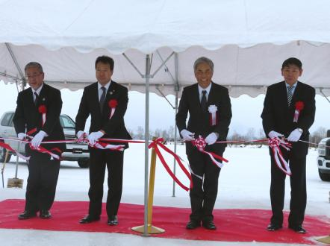](https://www.yrc.co.jp/release/download/download.php?no=2554&lang=en)*

*YRC President Hikomitsu Noji (second from right) and Asahikawa mayor Masahito Nishikawa (third from right) at tape-cutting ceremony marking opening of TTCH*